Home Maintenance Inspection
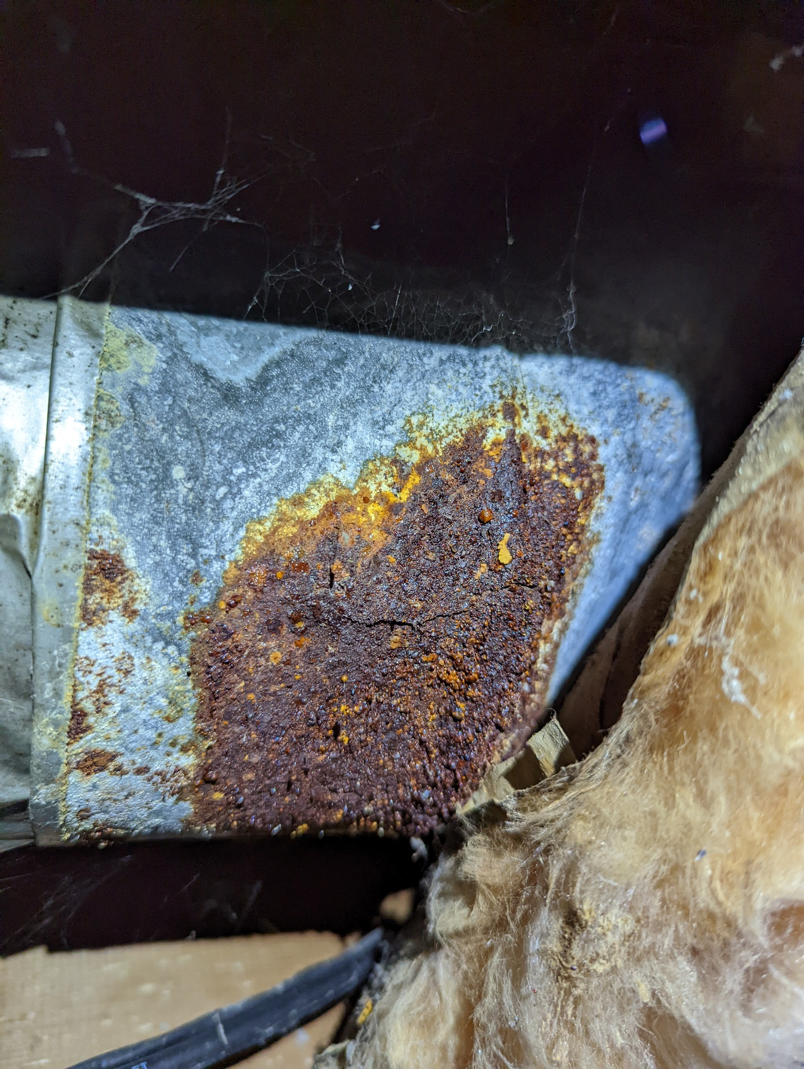

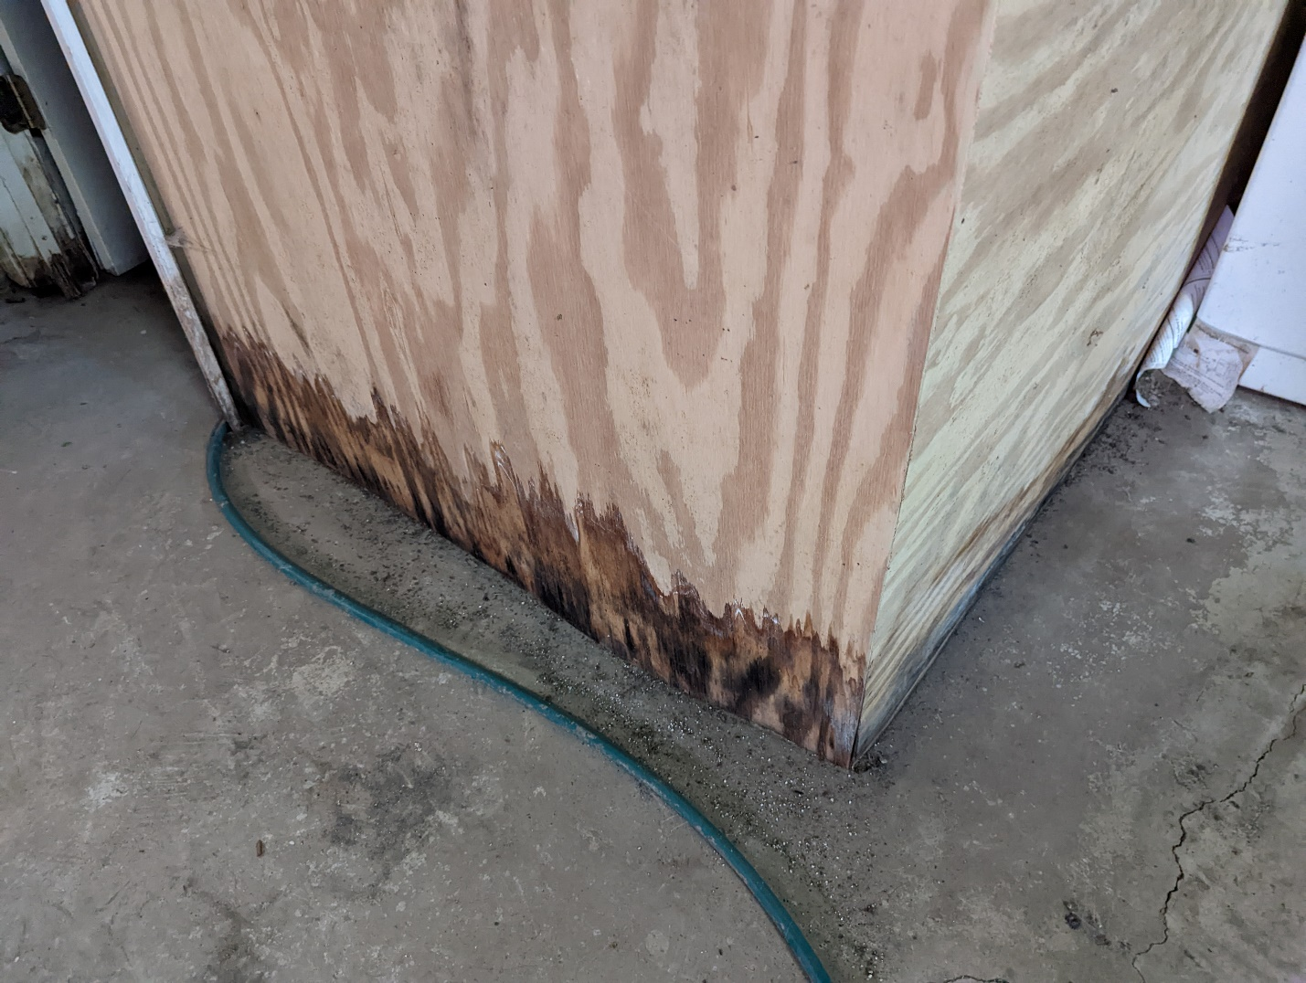

We know what it takes to get into a new house these days. Sometimes people have to offer way above the listing and waive inspections and appraisals just do get to the table in these cut throat situations. Fine, if that is the best decision for you at the time of purchase just get it done, then call us. You know this is a huge investment and the cost of an inspection shouldn’t get in the way of that.

But wait, what do you not know about your house? Are you going to be up at night sweating it out whether you just bought a money pit? Did I just hear a drip from the shower pan? Is there mold growing in my basement right now. Are there termites eating the floor joists under my kitchen? That floor sure is squeeky, I wonder what is causing that?

ACM inspects multiple houses every day, we know what to look for to compile a “honey do” list for you and make sure minor defects don’t lead to major ones and cost you several thousands in the next few years. We inspect everything from new Construction to 140 year old homes. Every home is unique and we know what to look for to make you house last for years to come.

In newer homes we use thermal imaging more in depth that on an older home. In older homes we try to point out the major defects and not focus on more of the cosmetic ones. No matter how new or old the house that you are buying, there are always items that we will identify that may affect the longevity of the home and reduce long term cost. Let us do an inspection after you move in to identify which items you can address now that may save you thousand in just the next few years.

In addition to maintenance inspections, ACM is now offering showing “walk throughs.” If you have a good feeling about a house that has just come on the market we will go with you to the showing, as a consultant, and advise of an major defects with the Roof, Foundation, HVAC, Pluming or Electrical Panel.

Call or book online today.

